Edward Jenner School

Allergy Safety Policy

 | Date | Signed
Date reviewed | September 2026 | Amy Rodgers
Ratified by | September 2026
Date of next review | September 2027

Aims and Objectives

1.1 Aims and Intent
This policy aims to provide a clear, consistent, and cohesive framework which conforms with statutory requirements and that promotes a whole school approach to health care, welfare and wellbeing and the safe management of individual children or young persons (CYPs) and staff at Edward Jenner School (EJS) who live with specific allergies. We work in conjunction with CYPs, parents/carers, staff in school, other local partners and Gloucestershire County Council, aiming to ensure that all allergies are taken seriously and dealt with in a professional and appropriate way. This policy will be publicised and made readily accessible to parents and staff on the school website and are made available in hard copy on request.
We are committed to meeting our obligations regarding the welfare and wellbeing of our school’s community through a whole school approach. By our actions we will work proactively to:
- Minimise the risk of exposure within the school setting
- Encourage self-responsibility
- Learn avoidance strategies
- Have robust plans for an effective response to possible emergencies
- Ensure inclusivity for all CYPs

1.2 Equality
EJS is clear about the need to actively support CYPs with medical conditions to participate in school life. EJS will consider what reasonable adjustments need to be made to enable these CYPs to participate fully and safely in all aspects of school life. Risk assessments will be carried out so that planning arrangements take account of any steps needed to ensure that CYPs with medical conditions are included. In doing so, CYPs, their parents and any relevant healthcare professionals will be consulted.
The Equality Act 2010 places statutory duties on local authorities and education providers, intended to provide equality of opportunity for all including those who are disabled. Under the Act a person is considered disabled if they have a physical or mental impairment that has a substantial and long-term negative effect on their ability to carry out normal daily activities. Case-law has established that severe allergies can fall within this definition. Seasonal rhinitis (such as hay fever) is explicitly excluded from the definition of disability, unless it aggravates the effect of another health condition.

1.3 Context
Food allergies are increasing in both developed and developing countries, especially in children and the severity and complexity of food allergy is also increasing. Food allergy can be fatal and an appropriate diagnosis is essential in parallel with the need for clear food labelling worldwide.
Around 5-8% of children in the UK live with a food allergy. These young people are at risk of anaphylaxis, a potentially life-threatening reaction which requires an immediate emergency response. 20% of severe allergic reactions to food happen whilst a child is at school and these reactions can occur in children with no prior history of food allergy. It is essential that staff recognise the signs of an allergic reaction, symptoms and can manage it safely and effectively.
It is possible to be allergic to anything which contains a protein, however most people will react to a fairly small group of potent allergens. (See Appendix 1 for a list of common allergens.)
Schools have a legal duty to support CYPs with medical conditions, including allergy.

1.4 Objectives
The Allergy Safety Policy at Edward Jenner School is in operation to ensure that every student, member of staff and visitor will be well looked after in the event of an allergy related incident, no matter how minor or major. EJS holds the following principles to ensure this:
- To comply with all relevant environmental legislation, regulations and requirements.
- To encourage proactive steps to keep CYPs safe.
- To ensure CYPs from diverse backgrounds, ethnicities or different cultural heritages are not disadvantaged when dealing with allergies and food labelling.
- To work with any external catering providers to establish a robust process and documentation for menu planning, food labelling, storing, avoidance of cross-contamination, stock ordering of food/drink used at the school.
- To provide an effective staff awareness programme on food allergies and intolerances, possible symptoms (anaphylaxis) recognition and actions to take.
- To develop a CYP awareness programme through PHSE (Thinking) and other curriculum areas such as; Science, the Character & Purpose (CP) Programme and any individual provisions put in place for our CYPs.

Legislation and Guidance

2.1 Legislation
This policy meets the requirements of the Department for Education (DfE) Allergy Safety in Schools Statutory Guidance (2026). and refers to the DfE’s statutory guidance on school allergy safety measures. These documents are drawn from the following legislation setting out the legal powers and duties that govern school allergy safety:
- Under section 100 of the Children and Families Act 2014, schools have a duty to support CYPs with medical conditions. These responsibilities are explained in the statutory guidance on supporting CYPs at school with medical conditions. Section 34 of the Children’s Wellbeing and Schools Act 2026 amends this by placing a further requirement to have allergy safety policies, publish them and keep them under review.
- The Food Information Regulations 2014 require all food businesses, including school caterers, to show allergen ingredients information for the food they serve. This makes it easier for schools to identify the food that CYPs with allergies can and cannot eat and outlines the requirements for the labelling of allergens on PPDS foods. Read the Food Standards Agency’s advice for schools, colleges and nurseries.
- The duty of care under section 3 of the Children Act 1989 for any person with the care of a child to do all that is reasonable for the purposes of safeguarding or promoting the welfare of the child;
- The duties to safeguard and promote the welfare of pupils and students under sections 20 and 175 of the Education Act 2002, the Education (Independent School Standards) Regulations 2014 (and associated statutory guidance Keeping Children Safe in Education);
- The duty of the employer under section 2 of the Health and Safety at Work etc Act 1974 to take reasonable steps to ensure that employees are not exposed to risks to their health and safety;
- The duties under the Equality Act 2010 to provide equality of opportunity for all, including those who are disabled.
- The Special Educational Needs and Disability (SEND) SEND code of practice: 0 to 25 years.

Roles and Responsibilities

3.1 The Proprietor/Headteacher (Manda Brookes) is responsible for:
- Ensuring EJS has a strategic vision for the management of allergy risk assessment and emergency procedures and ensuring EJS’s arrangements to identify and safeguard the wellbeing of CYPs, because of their own or someone else’s allergy, are robust and effective
- Providing, as far as practicable, a safe and healthy environment in which people at risk of allergic reaction and anaphylaxis can participate equally in all aspects of school life and are not subject to bullying because of their condition
- Delegating the day-to-day responsibility for the effective delivery of this Policy to the Allergy Coordinator/Member of SLT
- Ensuring all visitors, volunteers, work experience students, sub-contractors are made aware of the school’s commitment to allergy management as part of Safeguarding
- Ensuring that the school provides appropriate training, information, instruction, induction and supervision on a regular basis to enable everyone to stay safe regarding allergies and their management in line with the statutory requirements and assessed needs, allowing for staff absences away from the school premises
- Ensuring First Aid staff training includes anaphylaxis management, including awareness of triggers, anaphylaxis and first aid emergency procedures
- Ensuring all training and attendees are logged and stored correctly and safely
- Ensuring adequate resources for managing allergies are available
- Ensuring the curriculum contains age-appropriate content so all CYPs can learn about allergies and how everyone can support those who have them
- Ensuring best practice in the labelling of foodstuffs and their contents
- Creating links at strategic level with Healthcare professionals and external catering providers and ensure at operational level that links are robust
- Ensuring that up-to-date allergy information for CYPs is accessible to all members of staff and that they know how and where to check for updated information
- Ensuring there is a workable School Emergency Plan in place that is known by all staff
- Ensuring an adequate risk assessment is undertaken prior to any school trips, excursions or offsite extra curricula activities for CYPs who have allergies
- Ensure staff leading a whole-school trip, excursion or off-site extra curricula activity have considered how they carry all relevant emergency supplies with them which is signed off on the Activity Preparation Form.
- Ensure current medical information is obtained as part of data collection at the commencement of each academic year and for any new CYP joining mid-year.
- Ensuring a copy of IHPs held by EJS for the CYP is sent to parents/carers for review and update with the Data Collection Form (see Appendix 2).
- Ensuring records of CYPs medically prescribed an AAI and its use are kept correctly
- Ensuring CYP documentation and in date medication are kept correctly and safely
- Where the CYP has an Individual Healthcare Plan (IHP), ensuring the involvement of healthcare and welfare professionals, school staff, parents/carers and the CYP in establishing IHPs
- Encouraging parents/carers to provide Allergy Action Plans (AAPs) completed and signed by a healthcare professional that can be kept with their medication with copies made available for all staff to access and help the school support the CYP
- Ensuring this Allergy Safety Policy is available on the school website for parent/carers highlighting how the school is managing CYPs with allergies
- Monitoring the effectiveness of this Policy to ensure it remains fit for purpose

3.2 Allergy Coordinator/Member of SLT (and Manda Brookes) is responsible for:
- Following all legal requirements, recommended best practice and whole school procedures pertaining to allergies within the school context
- Reporting to the Deputy Head or Head/Proprietor regarding CYPs with allergies
- Leading on the training of staff regarding allergy medical needs and their identification and management
- Monitoring where there is school “baked and shared”, food purchased externally, or home baked items are brought into school
- Ensuring medication is stored in a rigid box and clearly labelled with the CYP’s name and a photograph (older CYPs should carry their AAIs and medication with them)
- Be trained in the use of an Adrenaline Auto-Injector (AAI) and be competent in performing any possible required prescribed medical treatment as outlined in the CYP’s IHP and/or AAP
- Ensuring that any other staff involved with those CYPs requiring the use of an AAI are also adequately trained and competent
- Ensuring all school trips, excursions or off-site extra curricula activities for CYPs are pre-checked so that ‘safe’ food is provided, if relevant, or that an effective control is in place to minimise risk of exposure for CYPs with allergies
- Ensuring the school has an audited spare supply of in date AAIs that are kept in a safe space at room temperature that is accessible, secure but not locked away and all staff are aware of the location
- Monitoring the use of all AAIs to ensure they are within the expiry date including those brought into the school by CYPs or external sources and are of the correct dosage
- Arranging for the correct disposal of out-of-date AAIs
- Arranging the purchase of replacement AAIs when AAIs are used or become out-of-date
- Where anaphylaxis is suspected in an undiagnosed individual, calling the emergency services and state ANAPHYLAXIS is suspected, then following their advice as to whether administration of a spare AAI is appropriate
- Recording all emergency uses of AAIs or reports of suspected emergencies
- Ensuring that, if a CYP notifies school that they are no longer allergic to a food, this information is checked prior to updating records and the IHP (if applicable).

3.3 The Admissions Officer is responsible for:
- Follow all legal requirements, recommended best practice and whole school procedures pertaining to allergies within the school context
- Liaising with parents/carers of CYPs with known declared allergies to produce a risk assessment for their child that includes sharing of information, allergy management, risk minimisation and emergency actions.
- Wherever possible using an AAP for CYPs with recognised allergies and keeping it in the “Black Folders”. Ensuring copies of the AAP are also available for all staff to access in ‘Medical’ Folder in Staff Drive.
- If an additional written IHP is not required, ensuring that the AAP is viewed and treated with the same level of seriousness.
- Ensuring all copies of the AAP/IHP located around the school and/or on IT systems are identical if an updated version is received.
- Ensuring that the “WHOLE SCHOOL INFO SHEET” is regularly updated with CYP’s allergens, summary of usual treatments and a link to their AAP. Ensuring that staff are notified when these updates are made.
- Where an AAP has not been received for a CYP with recognised allergies, or if the medication information is not clear, liaising with GP/school nursing team, to obtain an up to date copy and/or clarification.
- Ensuring that, if a CYP notifies school that they are no longer allergic to a food, this information is checked prior to updating records and the IHP (if applicable).
- Obtaining current medical information as part of data collection at the commencement of each academic year and for any new CYP joining mid-year. This will include sending a copy of IHPs EJS holds for the CYP to parents/carers for review and update with the Data Collection Form (see Appendix 2 for a list of what must be included).
- Recording CYPs medically prescribed an AAI and its use
- Encouraging parents/carers to provide Allergy Action Plans (AAPs) completed and signed by a healthcare professional that can be kept with their medication with copies made available for all staff to access and help the school support the CYP

3.4 First Aiders are responsible for:
- Following all legal requirements, recommended best practice and whole school procedures pertaining to allergies within the school context
- Report to the Head teacher regarding CYPs with allergies
- Wherever possible use an AAP for CYPs with recognised allergies and keep it with their medication.
- If an additional written IHP is not required, view and treat AAP with the same level of seriousness.
- Report any copies of the AAP/IHP located around the school and/or on IT systems are not identical when an updated version has been received.
- Ensure medication is stored in a rigid box and clearly labelled with the CYP’s name and a photograph (older CYPs should carry their AAIs and medication with them)
- Be trained in the use of an Adrenaline Auto-Injector (AAI) and be competent in performing required prescribed medical treatment as outlined in the CYP’s IHP and/or AAP as named members of staff
- Correctly dispose of out-of-date AAIs
- Reporting when AAIs are used or become out of date and require replacing
- Where anaphylaxis is suspected in an undiagnosed individual, call the emergency services and state ANAPHYLAXIS is suspected, then follow their advice as to whether administration of a spare AAI is appropriate
- Record all emergency uses of AAIs or reports of suspected emergencies

3.5 All Staff are responsible for:
- Following as directed all the requirements of the school, including all legal requirements, recommended best practice and whole school procedures pertaining to allergies within the school context
- Be aware of all CYPs in school who have known allergies as an allergic reaction could occur at any time, not just at breaks or mealtimes
- Any staff responsible for taking CYPs out of the building on a school trip or visit (this includes Cafe 76, Tesco runs, etc.) must check that all CYPs in their group with medical conditions, including allergies, are carrying their medication or, when appropriate, have their medication carried by a known First Aider in the CYP’s group. Those unable to produce their required medication would not be able to attend the excursion
- Check and assess where there is school “baked and shared”, food purchased externally, or home baked items are brought into school
- Complete appropriate anaphylaxis training and be confident to respond to an allergy emergency
- Ensure updates on information regarding CYPs allergies are read when notified
- Raise awareness about allergies and anaphylaxis amongst CYPs in the classroom and around school, especially in dining areas
- Encourage self-responsibility and learned avoidance strategies amongst CYPs living with allergies
- Help all CYPs understand which foods are safe for those with allergies and how they can support other CYPs with specific dietary needs to stay safe
- Highlight the need for anti-bullying of CYPs with the condition
- Any food-related activities must be supervised with due caution whilst following best practice for storing, preparing, cooking and serving food
- Update Gameplan sheets for their CYP with allergies information in discussion with the CYP

3.6 All Parents/carers are expected to:
- Notify the school of the CYP’s allergies, however mild you consider it to be
- Inform the school of any changes as soon as known
- Talk with your child, with or without allergy, about reasons to not share food at school and why their lunchbox and bottles must be clearly labelled with their name

3.7 Parents/carers of CYPs with an allergy are expected to:
- Talk with your child about allergy self-management, including what foods are safe and unsafe, how to read food labels, strategies for avoiding allergens, how to spot symptoms of allergy, how and when to tell an adult if experiencing an allergic reaction.
- Provide an AAP completed by a healthcare professional that can be kept with their medication and help the school support the CYP
- Contribute to the provision of an IHP in partnership with the school, and relevant healthcare professionals, where required.
- Provide any other written medical documentation, instructions and medications as directed by a health professional.
- Prior to residential trips, if requested, meet with the School or external Catering/Chef Manager to discuss any specific requirements relating to your child’s allergy (information from these meetings will be recorded by the Catering/Chef Manager)
- Be aware of the school Allergy Safety Policy and any arrangements for managing children with allergies and at risk of anaphylaxis
- Communicate regularly with the school to support our ability to keep our children safe and act immediately in the event of an allergic reaction
- Provide appropriate in-date medication (two AAIs) of the correct dosage and register their AAIs on the manufacturer’s websites to receive text alerts for expiry dates
- Providing appropriate foods to be consumed by the child if necessary
- Remove and replace medications after use or upon expiry
- Review the Policy and procedures with the school’s Head teacher and/or Member of Staff responsible for medical needs, the CYP’s doctor and the CYP (if age appropriate) after a reaction has occurred

3.8 All CYPs are expected to:
- Have a good awareness of known allergy, engaging in directed awareness programmes of learning within school through Thinking, PSE, Science, CP, and other lead activities
- Support peers with allergy to keep them safe
- Be sure not to exchange food with others
- As soon as they suspect that they, or another person, are experiencing signs of allergic reaction, tell an adult

3.9 CYPs with allergies are expected to:
- Have a good awareness of their allergy and support the knowledge of peers in helping keep them safe
- Be proactive in the care and management of their food allergies and reactions and medication
- Be sure not to exchange food with others and take care to avoid any foods with known allergens
- Read food labelling but, if unsure, avoid the food
- Avoid eating anything with unknown ingredients
- Know where their medication is kept and (if age appropriate and confident enough to administer their own auto-injectors) take responsibility for carrying AAIs on their person at all times
- As soon as they suspect they are experiencing signs of allergic reaction, tell an adult

School Processes for Managing Children with Allergies

4.1 identifying CYPS, staff and visitors with allergy
To ensure all CYPs with allergies are identified and documented correctly the school will:
- Seek current medical information at the commencement of each academic year and for any new CYP joining mid-year with the Data Collection Form (see Appendix 2 for a list of what must be included)
- Following up, via phone call, any disclosure of CYP allergy information to assess level of severity and required next steps such as IHPs, meetings, and medication.
- Request parents/carers to provide Allergy Action Plans (AAPs) completed and signed by a healthcare professional that can be kept with their child’s medication with copies made available for all staff to access
- Document any CYP with allergy on the “WHOLE SCHOOL INFO SHEET”, recording the allergen, summary of usual treatment, and a link to IHPs
- Produce a risk assessment for CYPs with known declared allergies that includes sharing of information, allergy management, risk minimisation and emergency actions
- Produce an Individual Healthcare Plan (IHP) (see Appendix 3 for template) that is kept centrally in the “Medical” folder in Staff Drive for all staff to access and paper copies kept in the “Grab Folder”
- Sending a copy of IHPs EJS holds for the CYP to parents/carers for review and update with the Data Collection Sheet
- Labelling CYP and staff “tags” with allergen symbols (see Appendix 1)

Every effort should be made to ensure arrangements for CYPs are in place for the start of the relevant school term, or within two weeks when joining mid-term. For members of staff, arrangements should be in place when they commence work. For visitors, information on allergy should be sought in advance of their visit wherever possible.
A list of individuals with known allergies (including up-to-date photos and lists of their known allergens and if an AAI is prescribed) will be kept in, or nearby to, places where food may be regularly served or handled. Such lists should be kept in areas accessible to staff only. A list will be displayed in the following areas, as well as digitally in the “Medical” Folder on the Staff Drive:
- Behind the Main Reception Desk
- Main School Staff Kitchen
- Science Prep Room
- CH100 Staff Kitchen
- Staff Room at 44
- Unroom
In areas that are accessible to CYPs, printed notice to remind staff to check the lists , and the closest location of a list will be displayed (see Appendix 10), including:
- Tortoise
- CH100 Makers Shack
- Laboratory
- Rooms used for lunch times
- CH100 Ground Floor Reception
- Main School Reception Notice Board

4.2 Documentation

4.2.1 Individual Healthcare Plans (IHPs)
Individual Healthcare Plans (IHPs) will be completed for all CYP with known allergy who;
- have an allergy which has a functional impact on them in school;
- are at risk of harm as a result of their allergy; and
- require arrangements which are additional to or different from those made generally in guidance laid out by this policy and the ‘EJS First Aid and Supporting Students with a Medical Condition Policy’.
Some allergies will have little or no impact on the CYP while they are at school or will not pose a risk to the CYP. Some allergies will not require arrangements which are additional to or different from those made generally. For example; if a CYP only needs non-prescription and they are permitted to carry and administer it through EJS policies, they would not require an IHP.
IHPs will include the key information requested from parents/carers as well as the support and steps that EJS will take to support that CYP; providing staff with the clarity about what they need to do and essential information to manage in an emergency situation (see Appendix 3 for template). This includes:
- The CYPs name, date of birth and a current photo
- Contact details for the CYP’s parents/carers
- Who needs to be aware of the CYP’s medical conditions and the support required
- A brief summary of the medical condition, its triggers, signs, symptoms and treatments
- The CYPs needs arising from their medical condition including any medication (dose, side effects and storage) and other treatments, time, facilities, equipment, testing, access to food and drink where this is used to manage their condition, dietary requirements and environmental issues
- An indication of how the medical condition may impact on the CYP’s learning and wellbeing
- The extent to which the child or young person is able to take responsibility for their own health needs including in emergencies. If a child or young person is self-managing their medication, this should be clearly stated, with appropriate arrangements for monitoring
- Details of the specific support or adaptations which EJS will put in place
- Clear arrangements for maintaining educational progress where absence or missed learning occurs due to medical conditions
- Details of any arrangements or procedures which may be required for school trips or other activities outside of the normal timetable that will ensure the child can participate.
- Information about what to do in an emergency, including whom to contact, and contingency arrangements.
- Where a CYP has a Personalised Care and/or Action Plan issued by a healthcare professional, it should be attached to their Individual Healthcare Plan.
- Medical and parental consent for staff to administer medicines such as adrenaline in the event of an allergic reaction or the emergency reliever inhaler in the event of an asthma attack.
- Where the CYP will or is likely to require medication to be administered while at school:
  - Details of any medication (dose, side effects and storage, and any arrangements for checking that it is in date) and how and when it should be administered
  - Instructions on how to identify the symptoms or complications or side-effects and how to respond
  - Written permission from parents/carers and/or healthcare professionals for medication to be administered by a member of staff, or self-administered during school hours
  - Where necessary, the names of specific members of staff who have been trained to administer the medication, together with cover arrangements in their absence
IHPs will be developed when new CYPs join EJS or when updates of information are provided (see Appendix 4 for a flow chart for creating and reviewing IHPs). They will be reviewed when needs or information have changed, a significant incident or “near miss” has occurred, or annually to ensure they remain relevant. IHPs will be developed in collaboration with the CYP and their parents/carers and will take account of any advice received by healthcare professionals.

4.2.2 Action Plans
Where individual CYPs have a known allergy to a food or insect stings, they must be issued with an appropriate Allergy Action Plan (AAP) by their healthcare professional. AAPs are designed to facilitate first aid treatment of reactions including anaphylaxis, by people without any special medical training or equipment other than access to an adrenaline device (e.g. AAI “pen”).
EJS recommends using the British Society of Allergy and Clinical Immunology (BSACI) Allergy Action Plans to ensure continuity. This is a national plan that has been agreed by the BSACI, Anaphylaxis UK and Allergy UK.
It is common for CYPs with allergies to also suffer from asthma. CYPs with asthma should be provided with an Asthma Action Plan. This provides everything staff need to know about a child or young person’s asthma in one place, including information about their triggers, symptoms, medicines to be used if they have asthma symptoms and when to seek emergency help when they have an asthma attack.
These Action Plans should be attached to the CYP’s IHP. Action Plans are reviewed and updated by healthcare professionals at regular intervals. Whenever an updated Action Plan becomes available, the CYP’s IHP should be reviewed to incorporate it.

4.2.3 Allergy Risk Assessments
EJS will conduct individual risk assessments for CYPs with an allergy. These will be reviewed annually and included in their IHP. Where suitable, additional risk assessments will be conducted for school trips and excursions, considering the new level of risk presented by a different environment.

4.3 Minimising and Managing Risks of exposure to known allergens
The school will:
- Adopt an ‘allergy-aware’ environment rather than a “nut-free” policy
- Include age-appropriate content for all CYPs to learn about allergies and how everyone can support those who have them
- Implement policies to avoid trading and sharing of food, food utensils or food containers
- Ensure all food provided by the school (including “baked and shared” food, food purchased externally, or home baked items brought into school) are checked and appropriately labelled; either with nutritional labelling or declaration that the absence of allergens cannot be guaranteed; before distribution
- Ensure staff planning activities consider the risk of exposure to allergens, for example in craft, science, musical or cooking activities, or where activities involve animals
- Ensure staff using food provided by the school check the labels, looking for highlighted allergens or disclosed allergens of the CYPs every time as ingredients of commonly used products may change over time
- Complete specific risk assessments to manage the risk of exposure to allergens in individuals with an allergy when planning external visits or trips (this includes Cafe 76, Tesco runs, etc.)
- Where children and young people have known allergies to airborne or contact allergens, reasonable measures will be discussed and put in place to manage the risk of the CYP being exposed to such allergens before they join the school on a case-by-case basis, while acknowledging the importance of the presence of animals (including dogs and guineapigs) within the school environment on the wellbeing and educational opportunities of all of our CYPs
- Not prevent CYPs from taking part in activities alongside their peers because of risk of exposure. Staff should find alternatives that do not exclude individuals. In the case that food is unsuitable for CYPs with allergies, then alternatives will be provided alongside, with the exception of insufficient alternatives for specific food sensory learning opportunities as EJS acknowledges the importance of this sensory work for individuals, requiring a case-by-case evaluation to be made.
- Staff will consider:
  - old food boxes or packaging may contain traces of allergens;
  - some products contain wheat flour, including ”play dough”;
  - some glues contain milk, wheat or soya;
  - bird feed may contain nuts and sesame.
- Expect bottles, other drinks, and lunch boxes provided by parents/carers to be clearly labelled with the name of the CYP for whom they are intended

Allergy Awareness and Staff Training

5.1 Allergy Awareness
The School supports the approach advocated by many allergy charities towards nut bans/nut free schools. They would not necessarily support a blanket ban on any particular allergen in any establishment, including in schools. This is because nuts are only one of many allergens that could affect CYPs, and no school could guarantee a truly allergen free environment for a child living with food allergy. They advocate instead for schools to adopt a culture of allergy awareness and education. A ‘whole school awareness of allergies’ is a much better approach, as it ensures teachers, CYPs and all other staff are aware of what allergies are, the importance of avoiding the CYPs’ allergens, the signs & symptoms, how to deal with allergic reactions and to ensure policies and procedures are in place to minimise risk.

5.2 Staff Training
EJS provides allergy training in the form of an in-person practical session using trainer AAIs (both EpiPen® and Jext®) and online sessions via The Key ('Allergies and Anaphylaxis for School Staff' and ‘Food safety and hygiene for school staff’) for all members of staff present during times when pupils are scheduled to be on site. This includes permanent staff, temporary staff, supply teachers, peripatetic staff, agency workers and regular volunteers. This training will ensure that all staff:
- Have an awareness of allergy, the risks it poses, how allergic reactions can occur and how to manage it
- Understand that allergy includes multiple conditions (food allergy, asthma, eczema, hay fever, others), which can co-exist
- Understand and can identify the main food allergens, and understand the difference between food allergy, intolerance and coeliac disease
- Can identify the range of symptoms of allergic reactions
- Understand and can recognise anaphylaxis
- Know how to respond in an emergency, including calling emergency services and how to locate and administer adrenaline in a case of anaphylaxis or an asthma reliever inhaler during an asthma attack. Including training on how to use the AAIs prescribed to the CYPs at EJS and the “spare” AAIs stocked by EJS
- Understand the impact which allergy can have on a child or young person’s wellbeing
- Understand EJS’s allergy safety policy
- Know how to check whether an individual is on the record of those with known allergies and how to use an Allergy or Asthma Action Plan
- Understand their responsibilities in reducing the risk of individuals with known allergy coming into contact with their known allergens
- Understand how to report an allergic reaction or case of anaphylaxis (whether an incident or a “near miss”).
This training will be renewed by all staff members annually and any new staff will undertake this training as part of their induction.

Supply, Storage and Care of Medication
Depending on their level of understanding and competence, CYPs will be encouraged to take responsibility for and to carry their own two AAIs on them at all times (in a suitable bag/container). It is advised that Year 9 CYPs and above should carry and self-administer their medication and parents/carers to discuss in IHP meetings depending on age and stage.
For younger children or those not ready to take responsibility for their own medication, there should be an anaphylaxis kit which is kept safely, not locked away and accessible to all staff. These will be stored at reception with the defibrillator at the main school and at ground floor reception desk at Century House; whichever is most appropriate for the CYP.
Medication should be stored in a suitable container and clearly labelled with the CYP’s name and photograph. The CYP’s medication storage container should contain:
- Two AAIs i.e. EpiPen® or Jext® *
- An up-to-date Allergy Action Plan
- Antihistamine as tablets or syrup (if included on allergy action plan)
- Spoon if required
- Asthma inhaler (if included on allergy action plan)
*AAIs should be stored at room temperature, protected from direct sunlight and temperature extremes.
It is the responsibility of the CYP’s parents/carers to ensure that the anaphylaxis kit is up-to-date and clearly labelled with their name, however the Allergy Coordinator/Member of SLT will check medication kept at school on a termly basis and send a reminder to parents if medication is approaching expiry.
Parents/carers should subscribe to expiry alerts for the relevant AAIs their child is prescribed, to make sure they can get replacement devices in good time. Parents/carers are responsible for the removal and safe disposal of expired or used AAIs.

6.1 “Spare” Adrenaline Devices
EJS will store* 2 spare Adrenaline Auto-Injectors (AAIs) on the grounds of the main school (44 London Road) and 2 spare AAIs on the grounds of Century House (100 London Road) to add an extra layer of reassurance for everyone involved and to create a safer and more inclusive environment for children managing severe allergies. They will all be 0.3mg EpiPens® as all CYPs are above the age of 6 years old. In the event of a CYP below the age of 6 enrolling at EJS, then EJS will purchase two 0.15mg AAIs as required by the statutory guidelines.
These will be stored at reception with the defibrillator at the main school (44 London Road) and at ground floor reception desk at Century House (100 London Road) to ensure they are accessible to all staff; and located no more than 5 minutes away from where they may be needed; in case of an emergency. They will be stored in pairs, so that if a second one is necessary it is on hand rather than needing to be obtained from elsewhere on site.
These will be labelled with the words “EJS SPARE” to avoid confusion with individual CYP’s AAIs.
They will be checked on a termly basis and checks will be recorded on a log sheet kept alongside them. Any “spare” AAIs that have been used or expired will be safely disposed of (see section 6.4) and replacements ordered within a week.

6.2 Older Children and Medication
Older children and teenagers should, whenever possible, assume responsibility for their emergency kit in discussion with the School parents/carers to prepare themselves for adulthood. They should ensure the storage of their AAIs enables them to have rapid access to their devices at all times. This includes; in lunch areas, playground and any off-site activities. However, symptoms of anaphylaxis can come on very suddenly, so school staff need to be prepared to administer medication if the CYP cannot.

6.3 Staff and Visitors and Medication
Staff and visitors should, whenever possible, assume responsibility for their emergency kit and should ensure they have rapid access to their devices at all times. This includes; in duty areas and any off-site activities. However, symptoms of anaphylaxis can come on very suddenly, therefore they must ensure that they have made the school aware of their allergy so that school staff can administer medication if the staff or visitor cannot. School staff need to be prepared to administer medication in these circumstances.

6.4 Safe Disposal of Medication
AAIs are single use only and must be disposed of as sharps. Used AAIs can be given to ambulance paramedics on arrival or can be disposed of in a pre-ordered sharps bin. There are small sharps boxes kept in the First-Aid Rucksacks and there are sharps bin kept in the following rooms:
- Science Lab Prep Room
- Main School Staff Kitchen
- CH100 Staff Kitchen
Expired or used AAIs belonging to individual CYPs will be returned to the parents/carers for removal and safe disposal. Expired or used AAIs belonging to staff or visitors will be returned to the staff/visitor for safe disposal.

Emergency Anaphylaxis Response Plan
All CYPs at risk of anaphylaxis should have an Allergy Action Plan (AAP) that describes exactly what to do and who to contact in the event that they have an allergic reaction. The plan should include First Aid procedures for the administering of adrenaline. These documents include parental consent to administer medications such as antihistamine to treat mild-moderate reactions. For those people assessed as not being at risk of anaphylaxis, the AAP also includes medical authorisation and parental consent to administer emergency adrenaline in the event of an anaphylaxis emergency.
The symptoms of anaphylaxis can occur very quickly and become life-threatening, so it is vital to recognise when a CYP is experiencing this type of reaction.
7.1 Mild to Moderate Symptoms of Allergic Reaction
- Skin rashes
- Swelling of the mouth, lips and/or face
- An unusual, tingling or itchy feeling in or around the mouth
- Feeling or being sick
- Stomach cramps

7.2 Responding to a Mild to Moderate Allergic Reaction
Mild to moderate reactions which do not involve the Airway/Breathing/Circulation can be treated with oral antihistamines. For a CYP, telephone their parent/carer or emergency contact to tell them about the reaction. Do not leave them unattended. The CYP does not normally need to be sent home or require urgent medical attention. They should be observed in a safe place for at least 60 minutes after reaction, as mild reactions can sometimes develop into anaphylaxis.
Other allergies such as asthma, hay fever or eczema can also affect a CYP’s health and school performance. Children and young people may need to bring both prescription and non-prescription medication (such as oral antihistamines, steroid nasal sprays and eye drops) to school, which they should be able to access if needed.
See Appendix 5 for a Flowchart for Allergic Reaction without use of Adrenaline Auto-Injector.
7.3 Severe Symptoms of Allergic Reaction - Signs of Anaphylaxis
- Airways: Swelling in the throat, tongue or upper airways (tightening in the throat, hoarse voice, difficulty swallowing)
- Breathing: Sudden onset wheezing, breathing difficulty, noisy breathing, persistent cough
- Circulation: Dizziness, feeling faint, sudden sleepiness, tiredness, confusion, pale clammy skin, loss of consciousness
If a CYP displays any of these symptoms, especially if they are known to have a severe allergy and to have consumed an ingredient they are allergic to, a swift response is vital. Anaphylaxis reactions to food usually begin within 30 minutes of eating the trigger food, but can sometimes occur 4-6 hours later. They typically affect the breathing (A and B, i.e. mimic an asthma attack) rather than the Circulation (blood pressure).

7.4 Responding to Anaphylaxis
Anaphylaxis reactions involve the Airway/Breathing/Circulation (“ABC”). Reactions usually progress quickly and can be life-threatening – so anaphylaxis always requires an immediate emergency response.
The vast majority of anaphylaxis reactions require the person to have eaten the food, although less severe allergic reactions can happen through skin or other contact. Anaphylaxis reactions due to skin contact are very rare. In some medical conditions such as mast cell disorders, anaphylaxis may occur without a clearly identified allergen or without ingestion of a food trigger. Emergency planning should therefore be based on the individual child or young person’s documented triggers and clinical history, rather than assuming ingestion of food is required.
Once started, anaphylaxis reactions progress quickly. Investigations into fatal anaphylaxis show that there is only a 20-30 minute window of opportunity during which steps can be taken to prevent death – therefore giving emergency adrenaline immediately and calling Emergency Services (999) is so important.
Anaphylaxis commonly occurs alongside mild symptoms or signs, such as an itchy mouth or skin rash. Anaphylaxis can also occur on its own, without a skin rash or other mild signs being present. Always consider anaphylaxis in someone with a known food allergy who has sudden difficulty in breathing. Giving adrenaline in this context is very safe and may be lifesaving.
Anaphylaxis (i.e. any reactions which involve the Airway/Breathing/Circulation) must be treated promptly with emergency adrenaline (for “How To Use AAIs” information sheets see Appendix 6 [EpiPen®] and Appendix 7 [Jext®]). The individual’s prescribed adrenaline device (AAI or nasal adrenaline device) should be used if it is available; if not, a “spare” adrenaline device can be used (see section 6.1 and section 7.5).
If in doubt whether the reaction is anaphylaxis, treat with adrenaline. Always dial 999 to request an ambulance if someone is experiencing anaphylaxis. The Emergency (‘999’) Operator can provide advice over the telephone if needed.
- Lie flat with legs raised (if breathing is difficult, allow to sit)
- Give adrenaline device without delay (use the school’s spare device if needed)
- Immediately dial 999 for ambulance and say ANAPHYLAXIS (ana-fill-axis) and consider self-transport to hospital from school with additional AAI and first aider on board.
After giving adrenaline:
- Stay with the person until ambulance arrives
- Do NOT stand them up as this can lead to cardiac arrest
- Keep them lying down or sat up (if struggling to breathe) even if things seem to be getting better
- Phone parent or emergency contact
If no improvement after 5 minutes, give another dose of adrenaline using a second device, if available. Re-dial 999 if no longer on the call.
Commence CPR at any time if there are no signs of life.
Many food-allergic children also have asthma. “Wheeze” is a common symptom of asthma and also happens during food-induced anaphylaxis. The Allergy Action Plan may include instructions to give a reliever medicine (e.g. using a salbutamol inhaler) after giving a dose of adrenaline if the person is still wheezing. Never give the reliever inhaler instead of adrenaline to treat anaphylaxis.
See Appendix 8 for a Flowchart for Allergic Reaction without use of Adrenaline Auto-Injector.
‘First Aid for Anaphylaxis’ posters (see Appendix 9) will be displayed alongside the printed lists of CYPs with known allergies and reminder notices.

7.5 Using “Spare” Adrenaline Devices in an Emergency Situation Without Prior Consent
The MHRA has clarified that a legal exemption under Regulation 238 of the Human Medicines (Amendment) Regulations 2017 permits a school’s “spare” Adrenaline Device (AD) to be used for the purpose of saving a life for a CYP or other person not known by the school to be at risk of anaphylaxis (i.e. who does not have medical authorisation/consent in place for the spare device). This might be, for example, a child presenting for the first time with anaphylaxis due to an unrecognised allergy, or an adult visiting the school premises. This provision should be reserved for exceptional circumstances only, that could not have been foreseen. Therefore, the spare AD can be used with anyone experiencing anaphylaxis in an emergency, for the purpose of saving their life.

7.5 Using “Spare” Asthma Reliever Inhalers in an Emergency Situation
The Human Medicines (Amendment) (No. 2) Regulations 2014 permits schools to buy salbutamol inhalers, without a prescription, for use in emergencies. The emergency salbutamol inhaler should only be used by children, for whom written parental consent for use of the emergency inhaler has been given, who have either been diagnosed with asthma and prescribed an inhaler, or who have been prescribed an inhaler as reliever medication. The inhaler can be used if the CYP’s prescribed inhaler is not available (for example, because it is broken, or empty). Further guidance is available on Emergency asthma inhalers for use in schools.

Procedures on Visits and Trips
EJS is committed to ensuring that CYPs with allergies are included in extracurricular activities such as school trips and visits.
In all trips and visits (including; Tesco runs, Cafe 76, nearby park) staff are responsible for knowing the allergies (indicated on the CYP’s “tags”) and usual treatments of the CYPs in their group and ensuring that they are carrying their medication or, when appropriate, have their medication carried by a known member of staff in their group. Staff are responsible for continuing the usual measures to minimise and manage CYPs with allergies as closely as possible considering the settings of the trip or visit.
For whole-school trips and visits the trip leader will be responsible for checking allergies for all CYPs to inform additional planning and preparation, involving parents/carers and other staff within the school to ensure that the activity remains safe for CYPs with allergy. All staff on trips will be responsible for minimising and managing the CYPs with allergies in their group.
For trips and visits to external venues, the venue staff (i.e., staff at a centre for residential trips) involved in food or activities involving potential allergens will have all allergies communicated to them clearly by the trip leader and will be encouraged to advise on how they will cater for CYPs safely ahead of the planned trip. In some cases, where external catering cannot provide satisfactory reassurance that they can cater for CYPs with allergies, parents/carers may be asked to provide food and drink for the CYP.
Trip risk assessments will include a general consideration of CYPs with allergies. Individual risk assessments will be conducted for any CYP at risk of anaphylaxis taking part in a trip off-site where the level of risk may differ from usual day-to-day activities due to the different environment.
CYPs at risk of anaphylaxis should have their own adrenaline device with them, either self-carried or carried by an identified member of staff in their group, depending on the age and stage of the CYP. There should be staff trained to administer adrenaline in an emergency in the group of the CYPs with allergies. It is not mandatory for schools to take “spare” AAIs on trips, however, EJS will take two AAIs on visits and trips in which the majority of CYPs are of attendance and only one site (CH100 or 44) is kept open. The AAIs will be retrieved from the site that is closed on that day.

Wellbeing of children and young people with allergy
EJS is committed to ensuring that all CYPs receive the highest levels of safeguarding and to ensuring that all children with medical conditions, including allergies, in terms of both physical and mental health, are properly supported in school so that they can play a full and active role in school life, remain healthy and achieve their academic potential. We acknowledge that CYPs with allergies may require an additional layer of safeguarding and support, including ensuring that bullying due to allergies does not take place.
The following steps aim to ensure that all CYPs with allergies feel safe and confident when attending school:
- All CYPs will receive lessons linked to allergy awareness to allow them to support their peers effectively and with kindness and understanding.
- Any accounts of allergy bullying will be treated seriously in line with EJS Anti-Bullying Policy.
- Staff will take care to ensure that they keep up-to-date information regarding CYPs allergies.
- Staff will engage with all training provided with care and attention.
- Additional monitoring is provided at meal times.
- Further planning and attention are given to CYPs with allergies when attending extracurricular trips, sports events and projects, including informing any external caterers of allergies and hypersensitivities.
- Regular communication to CYPs, parents/carers and staff about allergies, ensuring ongoing awareness and appreciation of the severity of the potential risks.
- Opportunities for CYPs with allergies to discuss worries or concerns with a named member of staff during “Game Plan”.
- Proactive engagement with new joiners with known allergies, setting out the school’s policies and the support available.

Serious Incidents and “Near Misses”
However effective policies are, they can never remove the risk of a serious incident involving a CYP, member of staff or visitor with a medical condition or allergy. Incidents may occur for reasons which are wholly beyond the control of EJS. EJS will approach serious incidents and “near misses” in a “no blame” spirit of seeking to learn lessons and address any issues which the incident identified, so that members of the school community are better protected in the future.

10.1 Recording
Any incident will be recorded in the accident book with a report including;
- Who was affected;
- What happened, when and where;
- Why the incident occurred (as far as is known);
- How staff and CYPs responded; what was done to support the individual; whether emergency services were called;
- How the incident concluded.

10.2 Reporting
The parent or carer of the CYP will be notified of the incident or “near miss” as soon as possible by either a phone call, email or note sent home (depending on severity of the incident). Parents and carers have the opportunity to discuss what happened and are encouraged to contribute their views to the consequent lessons learned review.
Not all serious incidents and “near misses” will result in an immediate emergency situation. In some cases, the impact may be delayed. The consequences might not become apparent until the CYP is back at home – and in some cases might not be seen for several days. In these circumstances parents and carers are always welcome to contact the school via email, text, phone call or in-person conversation to report.
Reports will be shared with the Headteacher as well as the Allergy Coordinator/Member of SLT responsible for allergy safety to allow them to consider what lessons are to be learnt. Report may also need to be shared with other agencies such as;
- The Local Authority
- The Health and Safety Executive
- Relevant healthcare professionals

10.2 Responding
An incident or a “near miss” with the potential to put a CYP’s life at risk is a serious event. EJS will consider its impact not only on the individual and their family, but also on those involved in responding and any CYPs who may have witnessed it.
EJS will take time to review the incident or “near miss” with the CYP and their parent/carers to try and address any concerns that the environment may not be safe. Any arrangements (such as IHPs) that are reviewed will involve the CYP and their parent/carer to ensure they are robust and appropriate.
The Headteacher and/or Allergy Coordinator/Member of SLT will consider the following:
- Could the school reasonably have foreseen an incident of this nature?
- Might the incident or near miss have been avoided through reasonable preventative steps? If so, what steps might have been taken?
- Were the circumstances of the incident covered by a policy (for example a medical conditions policy, allergy safety policy) and/or a plan (for example an Individual Healthcare Plan or a care or action plan issued by a healthcare professional) which set out how to respond to an incident of this nature?
- If so, was the policy and/or plan followed? If the policy and/or plan was not followed, are there staff training, capability or even disciplinary issues to consider?
- Was the policy or plan adequate? If the policy and/or plan was not adequate, what changes might be required?
- Should the school’s policies be changed as a consequence?
Relevant documentation; such as IHPs and policies, will be reviewed and altered if necessary. Any complaints can be made following the procedures outlined in the EJS Complaints Policy.

Links to other policies and monitoring arrangements
This policy should be read in conjunction with the following:
- EJS First Aid and Supporting Students with a Medical Condition Policy
- EJS Health and Safety Policy
- EJS Health and Safety-on-Outdoor and Education and Off-site Policy
- EJS Risk Assessment Policy
- EJS Safeguarding Policy
- EJS Admissions Policy
- EJS Anti-bullying Policy
- EJS Attendance Policy
- EJS Behaviour Policy
- EJS Primary RSHE Policy
- EJS Secondary RSHE Policy
- EJS Data Protection Policy
- EJS Complaints Policy

Appendices

Appendix 1 - Common Allergens and Symbols
The most common causes of food allergies relevant to this Policy are the fourteen food allergens:
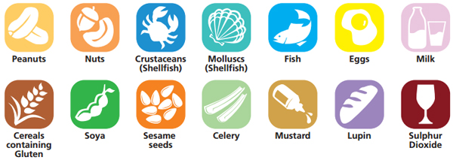
However, it is possible that any food has the potential to cause an allergic reaction. Contact with any food or materials containing a child’s allergen has the potential to cause an allergic reaction for that child.
Latex, chemicals, medicines, grasses, pollen, weeds, trees, pets, insect venom and animal dander (shedded flakes of skin) can also cause allergic reactions.
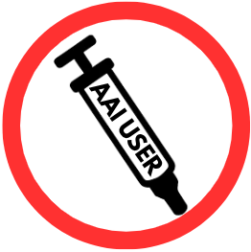
The symbols above will be used to indicate allergens on CYP and staff “tags”

The symbol (shown left) will be added to the “tags” if prescribed with an AAI.
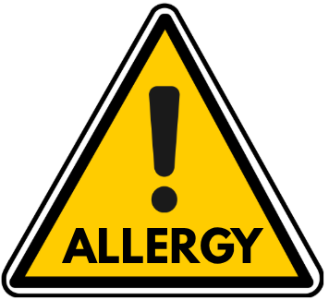

If a CYP has an allergy that is not listed above in the image, the symbol (shown left) will be used on the “tags” along with the name of the allergen written underneath.
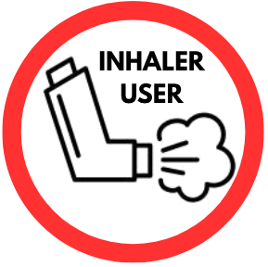

The symbol (shown left) will be added to the “tags” if prescribed with an inhaler.

Appendix 2 - Data Collection Form Necessary Information

The following key information about a CYP with allergy will be requested from parents/carers; and the CYP’s previous setting if applicable; and recorded in the CYP’s Individual Healthcare Plan (IHP):
  - Emergency contact details for the individual’s parents, carers or family
  - Permission to take an up-to-date photograph of the individual
  - What the individual’s known allergens are and whether the allergen is ingested, inhaled or absorbed
  - Whether the individual has an Allergy Action Plan; if so, it should be attached to the Individual Healthcare Plan
  - Whether the individual has been prescribed adrenaline devices and, if so, what make and dosage it is
  - Whether there is prior medical and parental consent for a “spare” adrenaline device or emergency asthma reliever inhaler to be used (notwithstanding that in an emergency situation that could not be foreseen, a spare adrenaline device can be used without prior parental consent)
  - Whether the individual also has asthma; if so, there should be an Asthma Plan attached to the Individual Healthcare Plan; this should include whether there is parental consent to use an emergency asthma reliever inhaler (if available) in an emergency
This list is regarding Allergies only and is not an exhaustive list. The information mentioned in section 4.2.1 must all be collected either through the use of the Data Collection Form or via other means of communication with parents/carers.

Appendix 3 - Individual Healthcare Plan Template

[INSERT NAME] - Individual Health Care Plan (IHP) for Allergy

Name of School | Edward Jenner School | Current Photo:
CYP’s Name |  | Current Photo:
Year Group | Year | Current Photo:
Date of Birth |  | Current Photo:
Address |  | Current Photo:
Staff who need to be aware
Staff responsible for support
Allergy
Include any known allergens
Likeliness to be aware they are having a reaction and ability to alert others
Allergy Management  Tick all which are relevant.  If any are ticked, please complete relevant annexes | - Allergy/Asthma Action Plan (issued by a healthcare professional)  - Care Plan (issued by a healthcare professional)  - Non-Prescription Medication  - Prescription Medication (issued by a healthcare professional)
To what extent is the CYP able to take responsibility for their own health needs
including in emergencies?
Impact on Education
Indicate potential harm if not managed properly, impact on learning, impact on wellbeing and any interactions between allergy and SEND
Arrangements for Support  Give details of the specific support or adaptations which EJS will put in place, within its educational remit and during meal/snack times  Outline measures to reduce the risk of contact with known allergens.  Note arrangements for maintaining educational progress where absence or missed learning occurs due to allergy. | Facilities –  Equipment –  Testing –  Allergies –  Diet (including access to food and drink) –  Timetable –  Activities –  Other Requirements –  Special Educational Needs –
Visits and Trips
Give details of any arrangements or procedures which may be required for school trips or other activities outside of the normal timetable that will ensure the child can participate.
Note any requirement for a risk assessment and prompts for specific issues which should be considered.
Emergency Response
If an Action Plan has been issued please write “See AAP” otherwise;
- Summarise signs and symptoms
- Set out what to do in an emergency
- Include who to contact
Last discussed with parent/carer: | Name: | Date:
Issued by: | Name: | Date:
Next planned review: | Name: | Date:
Family Contact Information
Name of Parent/Carer
Relationship to CYP
Phone Number
Additional Contact Name
Relationship to CYP
Phone Number
Hospital Contact
Hospital Name
Name
Phone Number
Name
Phone Number

GP Contact
GP Surgery Name
Name
Phone Number

“Spare” Medicine Consent
Consent from Parents/Carers for staff to administer medication as necessary during school hours including adrenaline in the event of an allergic reaction or the emergency reliever inhaler in the event of an asthma attack.
Name: | Relationship to CYP:
Signature: | Date:

Annex 1 - Allergy/Asthma Action Plan
Attach the Plan Here
Issued by: | Name: | Date:

Annex 2 - Care Plan
Attach the Plan Here
Staff Responsible for delivering/supporting delivery of care plan
Issued by: | Name: | Date:

Annex 3 - Non-prescription medication needed while in school
Medication | Medication Name –  Storage –  Dose –  Time –  Method of administering –  With or without food –  Side Effects and how to respond –  Administered by self or staff –  Supervised by –
Parental Concent: | Name: | Date:

Annex 3 - Prescription medication needed while in school
Medication | Medication Name –  Storage –  Dose –  Time –  Method of administering –  With or without food –  Side Effects and how to respond –  Administered by self or staff –  Supervised by –
Parental Concent: | Name: | Date:

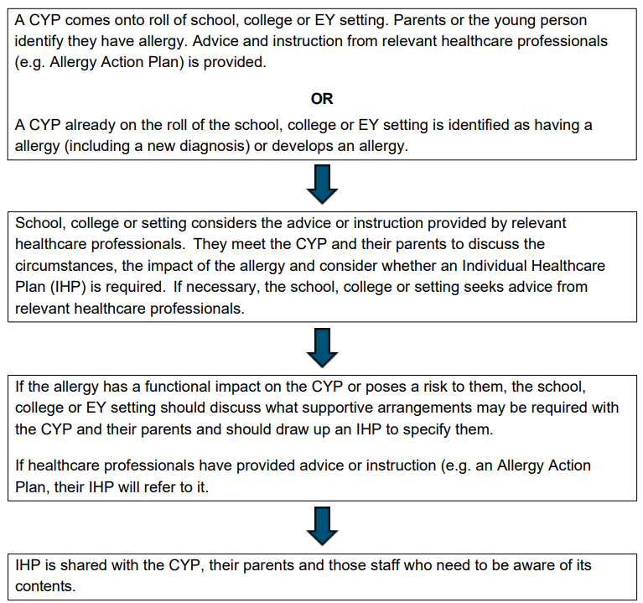
Appendix 4 - Flow Chart for Creating and Reviewing Individual Healthcare Plans

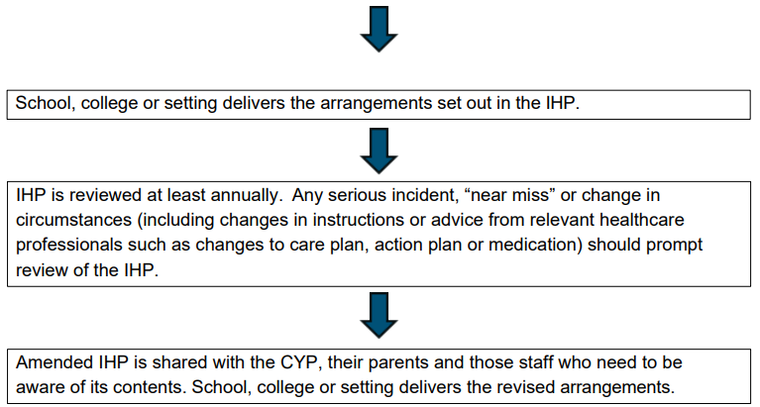

Appendix 5 - Flowchart for Allergic Reaction without use of Adrenaline Auto-Injector

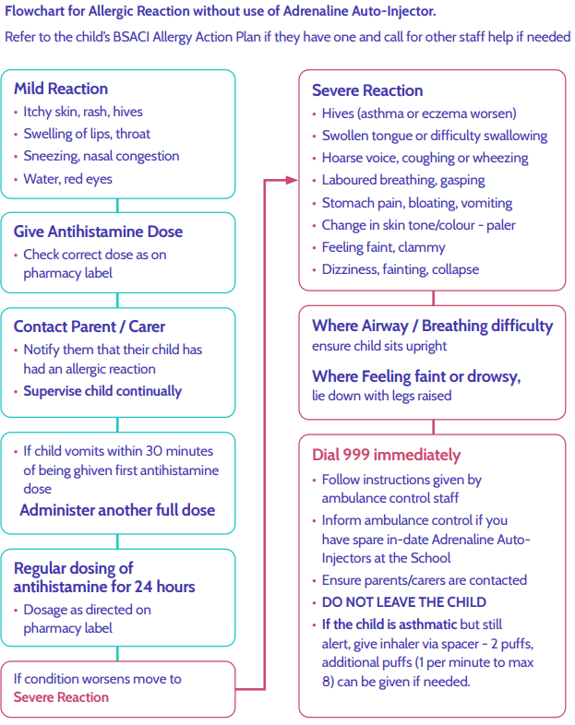

Appendix 6 - How To Use EpiPen® AAIs Information Sheet
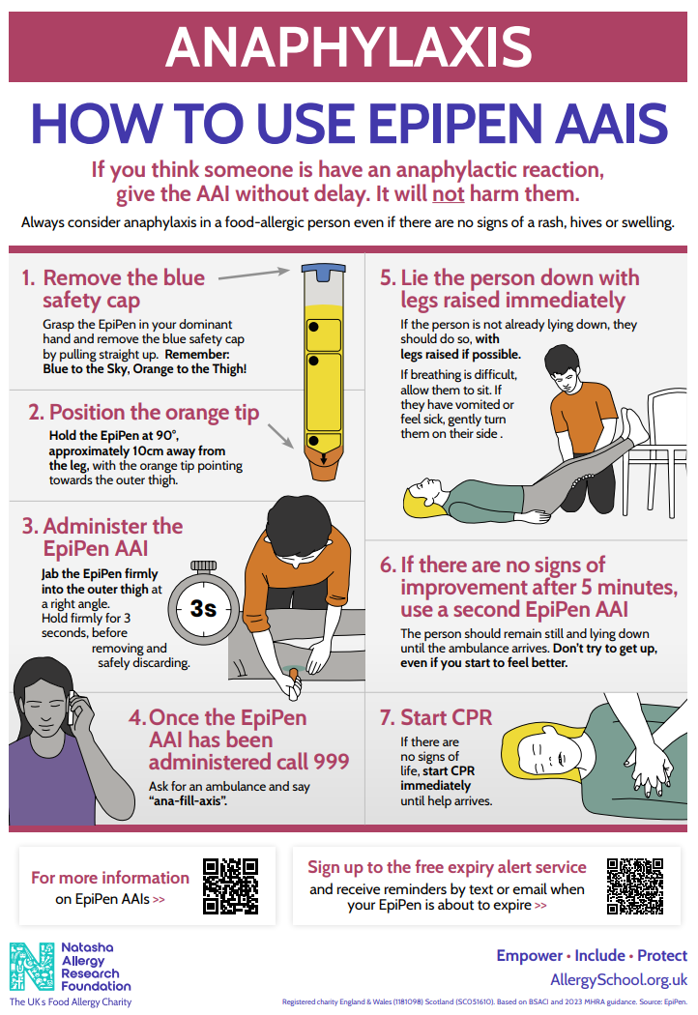

Appendix 7 - How To Use Jext® AAIs Information Sheet
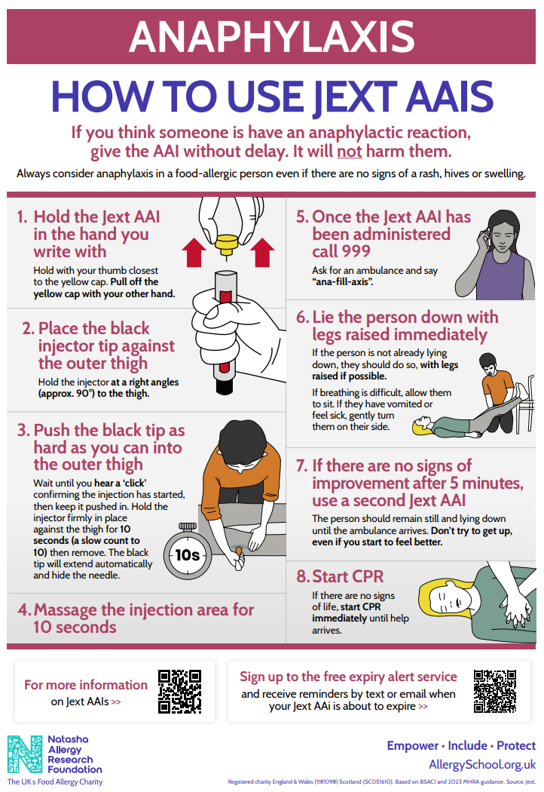

Appendix 8 - Flowchart for Allergic Reaction with use of Adrenaline Auto-Injector
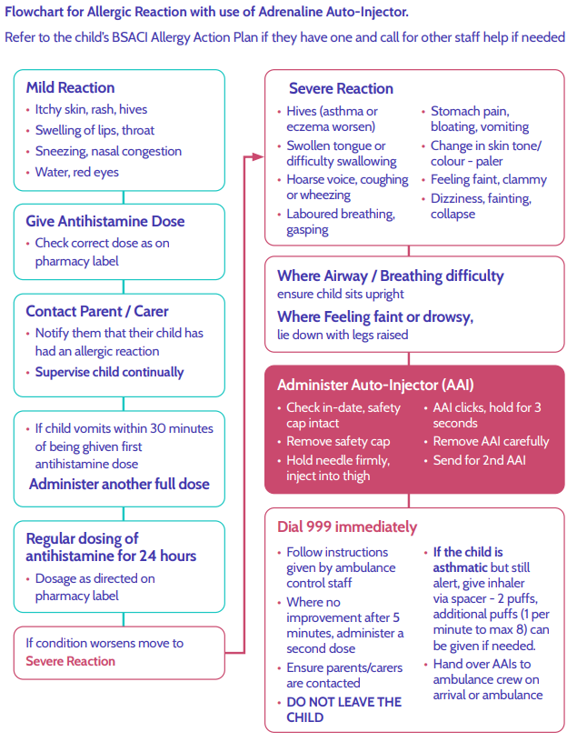

Appendix 9 - First Aid for Anaphylaxis Poster
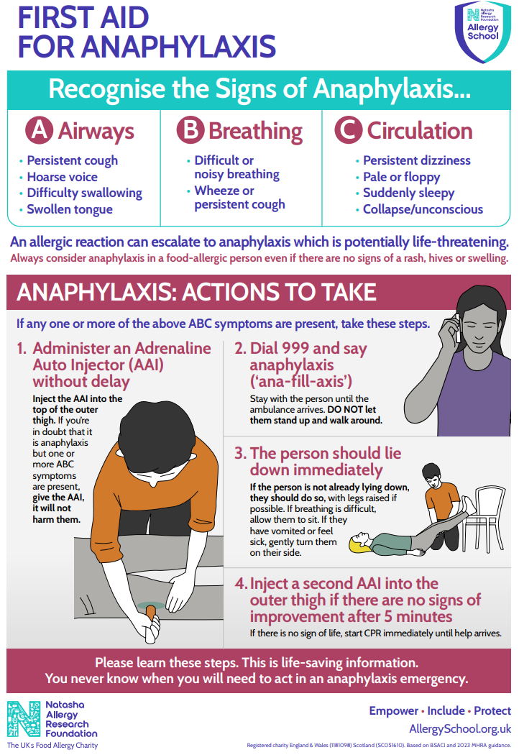

Appendix 10 - Allergy List Reminder Notice
